Table 1: Non-Corrected and Corrected Item–Total Correlations for a Test of Length 5
Item | n | M | SD | r-raw | Guilford | Cureton | Henrysson | CITC | AIOSR
q1 | 1000 | 3.43 | 1.55 | 0.797 | 0.643 | 0.661 | 0.699 | 0.659 | 0.725
q2 | 1000 | 4.23 | 1.48 | 0.773 | 0.615 | 0.629 | 0.683 | 0.632 | 0.696
q3 | 1000 | 3.21 | 1.28 | 0.746 | 0.606 | 0.618 | 0.699 | 0.617 | 0.679
q4 | 1000 | 3.33 | 1.28 | 0.751 | 0.614 | 0.627 | 0.707 | 0.624 | 0.687
q5 | 1000 | 3.35 | 1.39 | 0.761 | 0.612 | 0.625 | 0.691 | 0.625 | 0.689
Note. Internal consistency of the test: Cronbach’s α = 0.82.

Table 2: Non-Corrected and Corrected Item–Total Correlations for a Test of Length 10
Item | n | M | SD | r-raw | Guilford | Cureton | Henrysson | CITC | AIOSR
q1 | 1000 | 2.35 | 1.46 | 0.585 | 0.460 | 0.464 | 0.519 | 0.466 | 0.518
q2 | 1000 | 4.37 | 1.40 | 0.584 | 0.464 | 0.468 | 0.525 | 0.469 | 0.521
q3 | 1000 | 2.87 | 1.44 | 0.625 | 0.509 | 0.515 | 0.570 | 0.513 | 0.570
q4 | 1000 | 2.78 | 1.63 | 0.680 | 0.560 | 0.569 | 0.612 | 0.565 | 0.627
q5 | 1000 | 4.60 | 1.37 | 0.596 | 0.482 | 0.487 | 0.545 | 0.486 | 0.540
q6 | 1000 | 2.59 | 1.32 | 0.602 | 0.493 | 0.498 | 0.559 | 0.496 | 0.551
q7 | 1000 | 4.14 | 1.32 | 0.595 | 0.486 | 0.491 | 0.551 | 0.489 | 0.543
q8 | 1000 | 3.27 | 1.62 | 0.615 | 0.480 | 0.485 | 0.533 | 0.488 | 0.542
q9 | 1000 | 2.13 | 1.59 | 0.615 | 0.483 | 0.488 | 0.537 | 0.490 | 0.544
q10 | 1000 | 4.50 | 1.37 | 0.573 | 0.454 | 0.458 | 0.516 | 0.459 | 0.510
Note. Internal consistency of the test: Cronbach’s α = 0.81.

Table 3: Non-Corrected and Corrected Item–Total Correlations for a Test of Length 20
Item | n | M | SD | r-raw | Guilford | Cureton | Henrysson | CITC | AIOSR
q1 | 1000 | 2.45 | 1.35 | 0.432 | 0.347 | 0.348 | 0.388 | 0.349 | 0.385
q2 | 1000 | 4.40 | 1.34 | 0.509 | 0.432 | 0.434 | 0.479 | 0.432 | 0.477
q3 | 1000 | 2.50 | 1.39 | 0.425 | 0.337 | 0.338 | 0.376 | 0.339 | 0.374
q4 | 1000 | 3.03 | 1.57 | 0.514 | 0.422 | 0.425 | 0.464 | 0.424 | 0.468
q5 | 1000 | 3.32 | 1.42 | 0.527 | 0.445 | 0.448 | 0.492 | 0.447 | 0.493
q6 | 1000 | 4.24 | 1.44 | 0.435 | 0.343 | 0.345 | 0.383 | 0.346 | 0.382
q7 | 1000 | 3.74 | 1.27 | 0.437 | 0.357 | 0.359 | 0.400 | 0.359 | 0.396
q8 | 1000 | 3.67 | 1.56 | 0.481 | 0.386 | 0.388 | 0.427 | 0.389 | 0.429
q9 | 1000 | 2.10 | 1.58 | 0.495 | 0.400 | 0.402 | 0.441 | 0.403 | 0.444
q10 | 1000 | 3.28 | 1.52 | 0.559 | 0.475 | 0.479 | 0.520 | 0.476 | 0.526
q11 | 1000 | 2.52 | 1.54 | 0.452 | 0.356 | 0.357 | 0.395 | 0.358 | 0.396
q12 | 1000 | 2.19 | 1.37 | 0.436 | 0.350 | 0.351 | 0.391 | 0.352 | 0.388
q13 | 1000 | 3.40 | 1.33 | 0.452 | 0.369 | 0.371 | 0.412 | 0.371 | 0.409
q14 | 1000 | 2.65 | 1.32 | 0.487 | 0.408 | 0.411 | 0.454 | 0.409 | 0.452
q15 | 1000 | 3.29 | 1.63 | 0.513 | 0.417 | 0.419 | 0.457 | 0.419 | 0.463
q16 | 1000 | 3.02 | 1.44 | 0.403 | 0.310 | 0.311 | 0.347 | 0.312 | 0.345
q17 | 1000 | 4.03 | 1.53 | 0.510 | 0.420 | 0.422 | 0.462 | 0.422 | 0.465
q18 | 1000 | 2.16 | 1.27 | 0.497 | 0.422 | 0.424 | 0.470 | 0.423 | 0.467
q19 | 1000 | 4.74 | 1.29 | 0.465 | 0.386 | 0.388 | 0.431 | 0.387 | 0.427
q20 | 1000 | 3.61 | 1.51 | 0.488 | 0.396 | 0.398 | 0.438 | 0.399 | 0.440
Note. Internal consistency of the test: Cronbach’s α = 0.82.

Table 4: Non-Corrected and Corrected Item–Total Correlations for a Test of Length 30
Item | n | M | SD | r-raw | Guilford | Cureton | Henrysson | CITC | AIOSR
q1 | 1000 | 2.46 | 1.58 | 0.444 | 0.364 | 0.365 | 0.398 | 0.365 | 0.401
q2 | 1000 | 3.31 | 1.52 | 0.432 | 0.354 | 0.355 | 0.388 | 0.355 | 0.391
q3 | 1000 | 2.36 | 1.48 | 0.371 | 0.292 | 0.292 | 0.322 | 0.293 | 0.322
q4 | 1000 | 2.07 | 1.34 | 0.344 | 0.271 | 0.271 | 0.301 | 0.272 | 0.299
q5 | 1000 | 3.28 | 1.43 | 0.460 | 0.388 | 0.390 | 0.426 | 0.389 | 0.428
q6 | 1000 | 4.61 | 1.18 | 0.372 | 0.308 | 0.309 | 0.342 | 0.309 | 0.340
q7 | 1000 | 3.40 | 1.57 | 0.467 | 0.389 | 0.391 | 0.425 | 0.390 | 0.429
q8 | 1000 | 2.83 | 1.32 | 0.377 | 0.307 | 0.308 | 0.340 | 0.308 | 0.339
q9 | 1000 | 2.54 | 1.29 | 0.376 | 0.307 | 0.308 | 0.341 | 0.308 | 0.339
q10 | 1000 | 2.22 | 1.25 | 0.401 | 0.335 | 0.336 | 0.371 | 0.336 | 0.369
q11 | 1000 | 4.79 | 1.17 | 0.453 | 0.395 | 0.397 | 0.436 | 0.395 | 0.435
q12 | 1000 | 2.82 | 1.29 | 0.363 | 0.294 | 0.294 | 0.326 | 0.295 | 0.324
q13 | 1000 | 3.57 | 1.23 | 0.432 | 0.370 | 0.371 | 0.408 | 0.370 | 0.407
q14 | 1000 | 4.58 | 1.26 | 0.444 | 0.380 | 0.381 | 0.419 | 0.380 | 0.418
q15 | 1000 | 4.32 | 1.41 | 0.387 | 0.312 | 0.312 | 0.344 | 0.313 | 0.344
q16 | 1000 | 2.77 | 1.29 | 0.370 | 0.301 | 0.301 | 0.333 | 0.302 | 0.332
q17 | 1000 | 2.78 | 1.32 | 0.389 | 0.320 | 0.320 | 0.354 | 0.321 | 0.352
q18 | 1000 | 4.68 | 1.40 | 0.425 | 0.353 | 0.354 | 0.389 | 0.354 | 0.390
q19 | 1000 | 4.71 | 1.12 | 0.344 | 0.284 | 0.284 | 0.316 | 0.284 | 0.312
q20 | 1000 | 4.29 | 1.44 | 0.464 | 0.392 | 0.394 | 0.430 | 0.393 | 0.432
q21 | 1000 | 2.24 | 1.57 | 0.386 | 0.302 | 0.303 | 0.333 | 0.304 | 0.334
q22 | 1000 | 2.22 | 1.27 | 0.391 | 0.324 | 0.325 | 0.359 | 0.325 | 0.358
q23 | 1000 | 3.14 | 1.40 | 0.330 | 0.252 | 0.252 | 0.280 | 0.253 | 0.279
q24 | 1000 | 3.80 | 1.42 | 0.429 | 0.356 | 0.358 | 0.392 | 0.357 | 0.393
q25 | 1000 | 4.23 | 1.26 | 0.419 | 0.354 | 0.355 | 0.391 | 0.354 | 0.390
q26 | 1000 | 4.02 | 1.46 | 0.413 | 0.337 | 0.338 | 0.371 | 0.339 | 0.372
q27 | 1000 | 3.38 | 1.47 | 0.465 | 0.391 | 0.393 | 0.429 | 0.392 | 0.431
q28 | 1000 | 3.78 | 1.54 | 0.491 | 0.417 | 0.419 | 0.455 | 0.418 | 0.460
q29 | 1000 | 4.48 | 1.28 | 0.417 | 0.352 | 0.353 | 0.388 | 0.352 | 0.387
q30 | 1000 | 4.25 | 1.44 | 0.362 | 0.283 | 0.284 | 0.313 | 0.285 | 0.313
Note. Internal consistency of the test: Cronbach’s α = 0.83.

Table 5: Empirical Evaluation of Formulas for Correction of Item–Total Correlation for a Test of Length 41
Item | n | Max Mark | M | SD | r-raw | Guilford | Cureton | Henrysson | CITC | AIOSR
A1.1 | 22436 | 2 | 1.19 | 0.52 | 0.344 | 0.309 | 0.310 | 0.309 | 0.310 | 0.310
A1.2 | 22293 | 1 | 0.67 | 0.47 | 0.307 | 0.275 | 0.275 | 0.275 | 0.275 | 0.275
A1.3 | 21213 | 1 | 0.34 | 0.47 | 0.484 | 0.456 | 0.457 | 0.455 | 0.457 | 0.457
A2.1 | 22396 | 2 | 1.10 | 0.66 | 0.432 | 0.390 | 0.390 | 0.387 | 0.391 | 0.391
A2.2 | 22376 | 1 | 0.72 | 0.45 | 0.422 | 0.394 | 0.395 | 0.394 | 0.395 | 0.395
A2.3 | 22440 | 4 | 2.45 | 1.41 | 0.589 | 0.513 | 0.515 | 0.489 | 0.520 | 0.520
A3.1 | 22364 | 3 | 1.06 | 1.06 | 0.565 | 0.507 | 0.509 | 0.492 | 0.511 | 0.511
A3.2 | 21319 | 3 | 1.18 | 1.17 | 0.632 | 0.575 | 0.578 | 0.551 | 0.579 | 0.580
A3.3 | 21606 | 2 | 0.19 | 0.55 | 0.402 | 0.367 | 0.367 | 0.366 | 0.368 | 0.368
A3.4 | 21173 | 6 | 2.31 | 1.80 | 0.582 | 0.480 | 0.481 | 0.450 | 0.491 | 0.491
A4.1 | 22329 | 5 | 2.25 | 1.45 | 0.619 | 0.545 | 0.547 | 0.517 | 0.552 | 0.552
A5.1 | 22345 | 3 | 2.02 | 0.92 | 0.559 | 0.509 | 0.510 | 0.496 | 0.512 | 0.512
A5.2 | 22000 | 3 | 0.75 | 0.87 | 0.511 | 0.461 | 0.462 | 0.452 | 0.463 | 0.464
A6.1 | 22336 | 3 | 1.36 | 0.98 | 0.539 | 0.484 | 0.485 | 0.472 | 0.487 | 0.487
A6.2 | 21787 | 1 | 0.28 | 0.45 | 0.495 | 0.470 | 0.470 | 0.468 | 0.470 | 0.470
A6.3 | 21736 | 2 | 1.26 | 0.82 | 0.454 | 0.402 | 0.402 | 0.396 | 0.404 | 0.404
A6.4 | 21410 | 2 | 0.35 | 0.68 | 0.400 | 0.356 | 0.357 | 0.354 | 0.357 | 0.358
A6.5 | 22101 | 4 | 2.94 | 1.50 | 0.591 | 0.508 | 0.510 | 0.482 | 0.516 | 0.516
A7.1 | 22285 | 3 | 2.30 | 0.95 | 0.562 | 0.509 | 0.511 | 0.496 | 0.512 | 0.513
A7.2 | 22166 | 2 | 1.15 | 0.93 | 0.573 | 0.523 | 0.525 | 0.510 | 0.526 | 0.527
A7.3 | 21333 | 2 | 0.83 | 0.75 | 0.513 | 0.470 | 0.471 | 0.463 | 0.472 | 0.472
A8.1 | 22024 | 1 | 0.40 | 0.49 | 0.561 | 0.535 | 0.536 | 0.531 | 0.535 | 0.536
A8.2 | 20573 | 1 | 0.15 | 0.36 | 0.469 | 0.448 | 0.449 | 0.449 | 0.449 | 0.449
A8.3 | 18788 | 1 | 0.13 | 0.34 | 0.427 | 0.407 | 0.408 | 0.408 | 0.407 | 0.408
A8.4 | 20545 | 3 | 0.63 | 0.83 | 0.420 | 0.368 | 0.369 | 0.364 | 0.370 | 0.370
A9.1 | 20801 | 4 | 0.87 | 1.11 | 0.652 | 0.601 | 0.604 | 0.577 | 0.605 | 0.605
B10 | 22356 | 1 | 0.89 | 0.31 | 0.233 | 0.210 | 0.211 | 0.212 | 0.211 | 0.211
B11 | 22245 | 1 | 0.83 | 0.37 | 0.392 | 0.367 | 0.368 | 0.368 | 0.368 | 0.368
B12 | 21671 | 1 | 0.65 | 0.48 | 0.302 | 0.269 | 0.269 | 0.269 | 0.269 | 0.269
B13 | 22330 | 1 | 0.65 | 0.48 | 0.294 | 0.261 | 0.261 | 0.262 | 0.262 | 0.262
B14 | 22164 | 1 | 0.57 | 0.50 | 0.248 | 0.213 | 0.213 | 0.214 | 0.213 | 0.213
B15 | 22363 | 1 | 0.87 | 0.34 | 0.283 | 0.260 | 0.260 | 0.261 | 0.260 | 0.260
B16 | 21610 | 1 | 0.61 | 0.49 | 0.266 | 0.231 | 0.231 | 0.232 | 0.232 | 0.232
B17 | 21824 | 1 | 0.28 | 0.45 | 0.178 | 0.145 | 0.145 | 0.147 | 0.146 | 0.146
B18 | 22216 | 1 | 0.74 | 0.44 | 0.237 | 0.205 | 0.205 | 0.206 | 0.206 | 0.206
B19 | 21965 | 1 | 0.50 | 0.50 | 0.353 | 0.320 | 0.320 | 0.320 | 0.320 | 0.321
B20 | 22148 | 1 | 0.23 | 0.42 | -0.014 | -0.045 | -0.045 | -0.046 | -0.045 | -0.046
B21 | 21815 | 1 | 0.55 | 0.50 | 0.273 | 0.238 | 0.238 | 0.239 | 0.238 | 0.239
B22 | 21814 | 1 | 0.14 | 0.35 | 0.186 | 0.160 | 0.161 | 0.162 | 0.161 | 0.161
B23 | 21690 | 1 | 0.39 | 0.49 | 0.250 | 0.216 | 0.216 | 0.217 | 0.216 | 0.216
B24 | 21505 | 1 | 0.32 | 0.47 | 0.169 | 0.135 | 0.135 | 0.136 | 0.136 | 0.136
Note. Internal consistency of the test: Cronbach’s α = 0.88.

Table A: Mean Bias of Item–Total Correlation Estimators Across Test Lengths (Estimator − True Correlation)
k | r-raw | Guilford | Cureton | Henrysson | CITC | AIOSR
5 | 0.075 | -0.079 | -0.064 | 0.002 | -0.065 | 0.001
10 | 0.060 | -0.058 | -0.053 | 0.001 | -0.053 | 0.001
20 | 0.046 | -0.043 | -0.041 | 0.000 | -0.041 | 0.000
30 | 0.037 | -0.035 | -0.034 | 0.000 | -0.034 | 0.000
Note. k = number of items. Values are mean bias averaged over items and 500 simulation replications (N = 1000 per replication). Bias = estimator minus true item–factor correlation; positive values indicate overestimation, negative values indicate underestimation. CITC = corrected item–total correlation (Eq. 11); AIOSR = adjusted for item overlap and scale reliability (Eq. 12).

Table B: Mean Root Mean Square Error of Item–Total Correlation Estimators Across Test Lengths
k | r-raw | Guilford | Cureton | Henrysson | CITC | AIOSR
5 | 0.078 | 0.080 | 0.066 | 0.021 | 0.067 | 0.014
10 | 0.062 | 0.060 | 0.055 | 0.014 | 0.055 | 0.013
20 | 0.048 | 0.045 | 0.043 | 0.014 | 0.043 | 0.014
30 | 0.040 | 0.037 | 0.036 | 0.014 | 0.036 | 0.014
Note. k = number of items. Values are mean RMSE averaged over items and 500 simulation replications (N = 1000 per replication). Lower values indicate closer agreement with the true item–factor correlation. Abbreviations as in Table A.

Figure 1: Mean Bias of Six Item–Total Correlation Estimators as a Function of Test Length

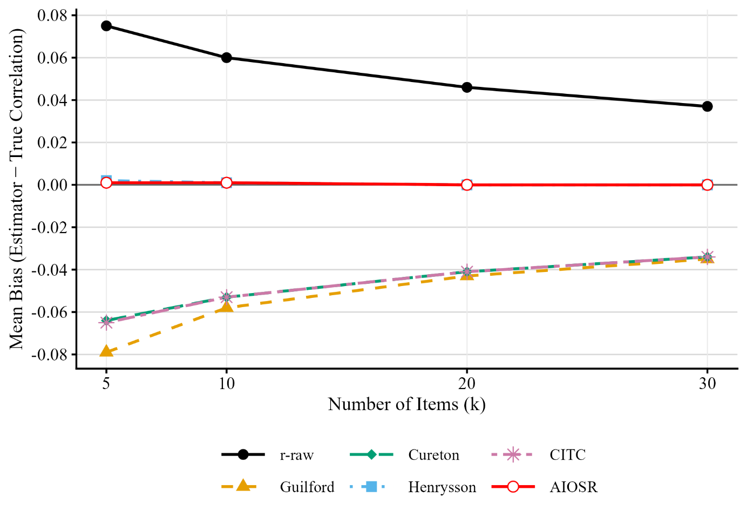

Figure 2: Mean Root Mean Square Error of Six Item–Total Correlation Estimators as a Function of Test Length

